**Project One: Analyze & Develop UI/UX Design**

Anthony Baratti

Southern New Hampshire University

CS-319 UI/UX Design & Development

Professor J. Carey

July 28, 2024

**Project One: Analyze & Develop UI/UX Design**

**Develop a layout of different screens for your digital wireframe that address the goals of the project:**

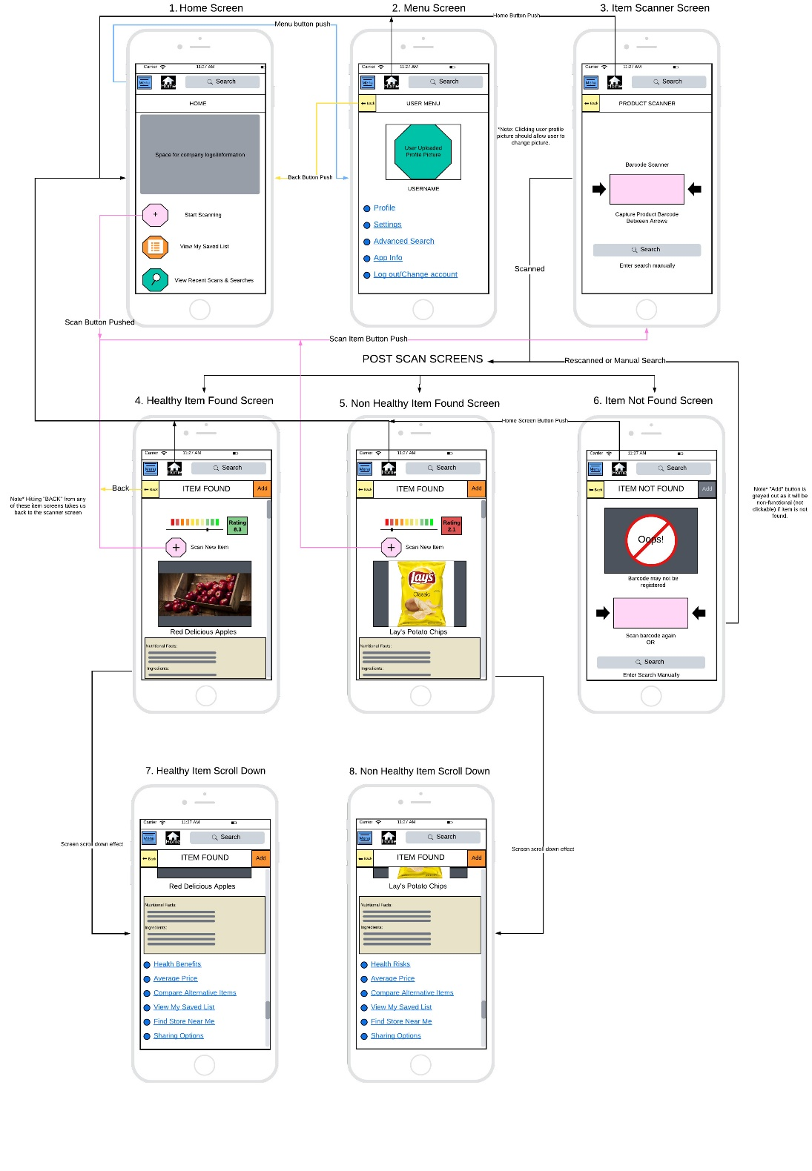

**PDF Version of Wireframe (Double click to open)**

**Create navigational elements and value-added features in your wireframe:**

Screen 1: Home Screen - On the home screen (after a user logs in via username and password or a quick click log in with social media) at the top is a blue clickable menu button and a black clickable home button with a house logo on it next to a text search bar. Below this navigation bar is a header bar that indicates which page you are on. Below the header bar is a space for the company name, logo, and any information (for example, if they want a daily message or an update message to appear, it can appear here). Below that are 3 large buttons. The clickable pink button with a + sign opens the 3. Item Scanner Screen. The other two buttons, for this wireframe, do not have function, but during design, they would be usable. The orange one with the list-icon would bring the user to their saved items list, and the green one with a magnifying glass would show the user their recent scans and searches.

Screen 2: Menu Screen – This screen utilizes the same navigation bar at the top, with no changes. Below, the header bar shows the user what screen they are on (in this case, “USER MENU”) and is accompanied by a yellow clickable back button. This button will take you to the previous screen. Below the header bar, there is a space for the user to upload their own image to represent the account (it would be designed to be clicked on to upload from the device) as well as display their user name. Below is a set of menu options that will be clickable to access their respective pages and the options that are contained within. Note, that these individual pages should contain the same navigation and header bar, displaying the name of the location within the application the user is in (for example, if “Profile” is clicked, the next page header should read “USER PROFILE”). Also, note that the home screen button will return the user to screen 1.

Screen 3: Item Scanner Screen – Again, note that the navigation bar exists with the blue menu button, the black home screen button, and the text search bar. Below is a header bar that displays what page the user is on (“PRODUCT SCANNER”) accompanied by a yellow back button. This screen's main function is to capture the barcode of the item within the pink frame (which would be showing what the device camera shows).

Screen 4, 5, 7, & 8: Healthy/Non-Healthy Item Found – These two screens (4 & 5) will appear according to the item that was scanned. They are the same except for what information will be displayed based on the item. On these screens, we again have the navigation bar with the blue menu and black home screen button, next to the text search bar. Below is the header bar which shows “Item Found!”, confirming that the item exists within the database. On the left of the header title is the yellow back button and on the right of the header title is an orange quick add button (this is not clickable yet but in design, it would add the item that was found to the user's saved list of items). Below the header bar is a visual display of the health level of the item (not clickable or adjustable). Red is unhealthy, orange through yellow is intermediate, and green is healthy. Accompanied by the sliding scale is a numeric representation in the form of a rating (on a scale of 0.0 to 10.0). The box in which the rating is held matches the color of the sliding scale the item lands on. Below is a clickable button that matches the button found on the home screen to scan a new item (pink with a + sign in it). Below the new scan button is the image displayed with the name of the found item, and below that is a section for nutritional facts and ingredients for the item. At the bottom, a non-functional (at this point, but later to be developed) clickable set of menu options written in blue underlined text. Each of these options will lead to a respective page. It is worth noting that the information presented on these screens needed to be expanded to fit all the information and options, so the screen (as indicated on the right-hand side of the wireframe) has a flick scroll option that allows the user to scroll down to access more pertinent information and buttons, keeping the presentation of most essential material at the top. It is also of note that when the screen scrolls down, the navigation and header bar do not scroll out of view from the user, which allows the user to maintain their navigation without having to scroll back up (Screens 7 & 8).

Screen 6: Item Not Found Screen – This screen will appear if an item is scanned that does not exist within the database, or the scanner has trouble reading the bar code. It contains the same navigation bar and includes a header bar that matches Screens 4 & 5 (item found) with a notable difference that the quick add button is grayed out (which indicates it cannot be used since no item was found). It displays an image at the very top that indicates an item is not found and provides a new scanner box for the user to rescan if they choose. There are instructions on how to continue by rescanning or searching by text.

**Explain the rationale behind your design decisions:**

The purpose and function of each screen is described above. The design above benefits the consumer/user by presenting a uniform and consistent layout, with the navigation bar always at the top, and each page having its own header bar that shows the name of the current screen along with further navigational buttons (such as back and quick add). The information displayed on each screen is ordered from most important to the user, to least important to the user, keeping the immediate needs of the user closer to the top of the screen, and in larger more noticeable depictions. Buttons are consistent not only in location but in color, size, and description (i.e. name and symbol). Some of the solutions that have been implemented (based on interviews and research) were to make clickable buttons large enough and far enough away from each other (a certain amount of pixel spaces away) so that they can easily be pushed while not pushing the wrong button or multiple buttons at once (known as “hit targets”) (Apple Inc., n.d.). Moreover, the colors of the buttons can be adapted quickly to accommodate the company’s logos or brand colors, such as all menu options (which are labeled in blue with underlines). These buttons have been kept uniform for this purpose (Apple Inc., 2024). The text size is big where attention is needed, and smaller for selective reading (areas the user may not care as much about). The contrast of text (on a white background) is black to keep visibility, and text spacing was kept in mind to not bunch up text for reading. Images and text are lined down the middle (The text may be left aligned but any box containing text, such as “Nutritional facts”) is aligned down the center (Apple Inc., n.d.). Based on interviews, a home screen has been added from the paper prototype design to allow users a quick way to return to their home screen, and a screen scroll option has been added to the “Item Found” screens to adhere to the best practices of not providing too much information or functionality into a small space (Screens 4/7 & 5/8). The header bar, which remains constantly below the navigation bar, even when the screen is scrolled up or down, provides a title to the screen content that is short and concise. It is suggested through best practices that if the screen stays idle, this navigation bar might temporarily hide itself to not become a distraction (something to further research through interviews on which parts to hide, i.e. just the title, or the buttons that accompany the title as well) (Apple Inc., 2023). Custom “Back”, “Home screen”, and “Menu” buttons have been implemented according to interviewed user needs and best practices that are made to look like standard (recognizable) respective buttons. According to user interviews conducted with a paper prototype, the presentation of the “Healthy” bar with its number rating (formally a green check mark or red x mark) was favored for clarity and meaning (the users thought the check and x meant found or not found, even though the screen declared item found or not found). The former symbols were misinterpreted and not specific enough to address the needs of the users.

**Discuss how your wireframe could be adapted to a digital watch:**

To adapt this application to a watch, it needs to be optimized for quick use, which means reducing the amount of content and providing the basic necessities of the application rather than the full app experience (Google LLC., 2024). To adapt this to “at a glance” usability, we want to remove any item images such as the apples or lays chips. Instead, we would display only the name of the item that matches the scanned item, and the corresponding slide scale bar and rating. This provides a quick look after a scan to determine its health rating. To keep the usable and necessary buttons spaced far enough to not hit multiple buttons or mistouch buttons (“hit target”) we can space the buttons around the edge of the screen. As a general rule, no more than two buttons with text, or three buttons with symbols/glyphs should be used in a row (Apple.developer.com, 2024). The menu button will provide a different functionality, rather than allowing access to options on a mobile device, the menu will be recreated to offer quick adjustments to the watch device. These buttons around the edge would include a home screen button, the menu button, the scan new item button, and a quick add (to my list) button. All of these buttons would share the same characteristics (size relative to each other but scaled, shape, and color) as their respective mobile application counterparts. A back button can be replaced by a left swipe (which would take the user back to the previous screen). On the home screen, the “Recent searches and scans” button could be removed completely, and the menu, my list, and scan buttons would be presented around the logo. The scan screen could contain a small box as well, but this could be unnecessary (I’ve never used a watch, and I’m not sure how the camera works on it) because the user might not be able to see the box while scanning the bar code. If no box is required, then a confirmation sound or vibration should be in place to allow the user to know when the item has been successfully scanned (so they don’t have to keep waving it around or wait, wondering if it scanned or not). Another effective implementation of the watch could be a voice-activated search bar instead of a text search bar. With fewer, but essential, options, the design for the watch will save time while providing the user with essential tools to complete their goals. Furthermore, with quick navigation and less information, the wearer will not experience fatigue holding their arm in a position to explore the information the watch application provides.

**Discuss how your wireframe could be adapted to a touch-based kiosk:**

According to Android.developer.com, window size classes require a lot of testing for the various sizes and layouts of large-screen adaptation. Considerations such as landscape and portrait presentation must be considered. However, beyond that, the layout should provide clear, unpixellated icons. It is also standard practice to put all buttons in or near the same location, either on the left side (down the side) or across the top or bottom. The information presented (or accompanying logos/designs) should fill out the screen, too much blank space is unappealing. Larger-sized fonts can be used, especially for titles or short descriptions (such as when the product is scanned, the product's name can be larger text than would appear on a mobile app). Larger text can also draw attention to certain things (such as the health rating number). It is also important to follow a visual hierarchy. Humans read top to bottom, left to right. So information that should appear to the user first should appear at the top and left most of the area where the information is held (such as display boxes). If the information is all over, the user could become confused. Keep the most important information first in this hierarchy, with less important information at the bottom (or below) (Apple.developer.com, 2024). Another consideration to expect is the keyboard for manual search entries. A full-size keyboard could pop up over the content (with a back button to get out of the keyboard) to allow users to enter letters without accidentally hitting the wrong keys. The kiosk could have a laser scanner (instead of a camera capture) that can be a hand-held device or attached to the screen, making it easier to know how to scan the item. At this point, the scan new item button can be removed as the scanning device would capture the barcode without a prompt from the application. As Apple.developer.com suggests, “Use placement to convey relative importance” (Apple.developer.com, 2024)., and this goes for the information presented, pushable buttons, and even device accessories. Making the scanner easy to see and use will be a very important part of the kiosk transformation of the application.

All in all, the best design should have a landscape layout, with wide buttons down the left-hand side (Home screen, menu, saved list, recent searches, navigation buttons such as back or quick add), the entire screen should be used, but not overcrowded, whether for information of images and logos. It is also a strong consideration for this type of application, used in a public place (kiosk) to have a very noticeable “Logout” button. The application should also be designed with auto log out after a certain amount of time has passed as well (or perhaps, only log in when you want to save to your list). Instead of adapting information to a scrolling screen (mobile app), display information left to right rather than scrolling down from top to bottom. For example, once an apple is scanned, the healthy meter and rating are shown at the top, and the image and nutritional information are shown side by side below the meter rather than the image on top of the nutritional information (like in the mobile screen display). Furthermore, because this will generally be the only information the user could be looking for in a kiosk scenario, having the alternative options that correlate on those mobile screens (7 & 8) could be tucked into a button labeled “More Options”. This is permitted because text in buttons is more acceptable on larger screens than simple symbols or one-word buttons. Of course, each of these screens must be accompanied by navigational buttons such as “Home screen” and “Back”. This allows us more (but not necessarily the most important) information per screen. The options still exist, they are just one further click away to hide the less important information, providing quicker interaction to those seeking the least information with the most value.

**REFERENCES:**

Apple Inc., (2024). *Controls.* Developer.apple.com. <https://developer.apple.com/design/human-interface-guidelines/controls>

Apple Inc., (2024). *Layout.* Developer.apple.com. https://developer.apple.com/design/human-interface-guidelines/layout

Apple Inc., (2023). *Navigation bars.* Developer.apple.com. https://developer.apple.com/design/human-interface-guidelines/navigation-bars

Apple Inc., (n.d.). *UI design do’s and don’ts.* Developer.apple.com. <https://developer.apple.com/design/tips/>

Google LLC., (2024). *Design Principles.* Developer.android.com. https://developer.android.com/design/ui/wear/guides/foundations/design-principles